

Table of Contents

I. About us 2

II. The idea of the project 2

III. Stages of work 3

Assembling the team 3

The process of creating 3

Finishing the project 3

Presenting the product 3

IV. Used Technologies 4

## About us

|  |  |  |
| --- | --- | --- |
| Name | Role | Grade |
| Gabriela Encheva | Scrum Trainer | 9v |
| Georgi Dimitrov | Front-End Developer | 9v |
| Veselina Varadeva | Frond-End Developer | 9v |
| Kristiqna Hristova | Back-End Developer | 9v |

## The idea of the project

“Star Gazers" is a quiz game that takes players on an educational journey through space. Players can learn some fascinating facts and intriguing mysteries about the universe.​

Also If you play this game you can test your knowledge. ​

The game covers a wide range of topics including astronomy, the solar system more.

## Stages of work

|  |  |
| --- | --- |
| № | Stages |
| **1st week** | *Assembling the team* We gathered and distributed the roles, so each person can work on the field that is most competent with. We started thinking about an idea for the project |
| **2nd week** | *The process of creating* Every week we met and discussed how we were progressing with the project. Each member fulfilled their duties and if we fell behind with our project we helped each other. |
| **3rd week** | *Finishing the project* After we finished with the project and the documentation, we fixed some bugs and made the overall user experience a bit more pleasant. |
| **4th week** | *Presenting the product* After weeks of hard working and sleepless nights we finished the project and now it is ready to be presented. |

## Used Technologies

1. C++ - for creating the app.
2. Github – for the synchronization.
3. Raylib – for app visualization.
4. MS PowerPoint – for creating presentation.
5. MS Word – for creating documentations.
6. Visual Studio 2022

## Block diagram

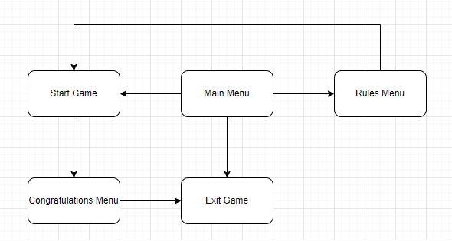

## Functions

|  |  |
| --- | --- |
| Type | Name |
| void | Menu() |
| void | Quiz() |
| void | Rules() |
| void | GameWon() |
| bool | CheckMouseClickOnOption  (int optionIndex, int mouseY) |